QUESTION 3 OF QB :

Draw a **CLASS DIAGRAM** for the scenario given below.This is an example that models University Courses. Assume three classes' such as course, lecturer, student and an interface person. Each course objects maintains a list of student on that course and lecturer who has been assigned to teach that course. The course object has behavior that allows adding and removing student to and from course, assigning the teacher and getting a list of currently assigned student and currently assigned teacher. A teacher may teach several courses but a course only has a single teacher .A lecturer object maintains a list of courses that it teaches, course is attended by 0 or more student and student may attend multiple courses. A person interface will have getName() and getEmailAddress() method both lecturer are shown to be the types of person.

ANSWER :

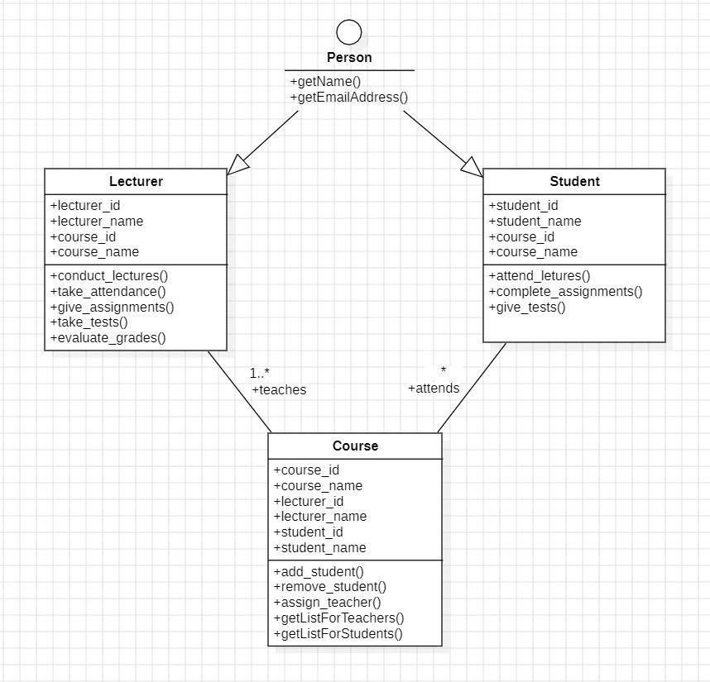

1. Draw a **CLASS DIAGRAM** using Star UML for the scenario given below. This is an example that models ATM machine system. Assume 12 classes' such as Bank, customer, ATMinfo, Debit card, Account, ATM transaction. Each bank objects maintains a list of customers and the customers will be doing ATM transactions. The account class includes current account and saving account class. The ATM transactions include withdrawal, query, transfer, and pin validation. One account holder can do multiple ATM transactions. The bank maintains one ATM. Current and savings account are the dependencies of Account. **(JOURNAL KA 1ST PRACTICAL)**
2. Study and implement **DEPLOYMENT DIAGRAM** for an ATM machine with nodes as customer and employee console, ATM machine, Card reader, Client Desktop, Database and webpage. **(JOURNAL KA 10TH PRACTICAL)**
3. Draw a **CLASS DIAGRAM** for the scenario given below.This is an example that models University Courses. Assume three classes' such as course, lecturer, student and an interface person. Each course objects maintains a list of student on that course and lecturer who has been assigned to teach that course. The course object has behavior that allows adding and removing student to and from course, assigning the teacher and getting a list of currently assigned student and currently assigned teacher. A teacher may teach several courses but a course only has a single teacher .A lecturer object maintains a list of courses that it teaches, course is attended by 0 or more student and student may attend multiple courses. A person interface will have getName() and getEmailAddress() method both lecturer are shown to be the types of person. **(ON THE 1ST PAGE OF THIS PDF)**
4. Draw a **COMPONENT DIAGRAM** for ATM machine and show the relationship among components in a system having components like ATM machine, Customer console, Bank database, card reader, webpage, employee console and client desktop. The card reader, web page and client desktop is dependent on the bank database. There is an interface to ATM machine, Bank database, webpage, card reader and client desktop. **(JOURNAL KA 9TH PRACTICAL)**
5. Create a **COLLABORATION DIAGRAM** for ATM system with lifelines as Account, ATM machine, Bank client, Bank account, cash, checking account and print receipt. **(JOURNAL KA 7TH PRACTICAL)**
6. Draw a **USE CASE DIAGRAM** for ATM system with actors like operator, customer, and bank. Customer uses Bank ATM to check balance of his/her account. Transfer funds. Operator provides maintenance, repair, system shutdown. All these use cases also involve Bank actor and is related to customer transactions pin validity and all other services. **(JOURNAL KA 2ND PRACTICAL)**
7. Create a **COLLABORATION DIAGRAM** for ATM system with lifelines as Account, ATM machine, Bank client, Bank account, cash, checking account and print receipt. **(JOURNAL KA 7TH PRACTICAL)**
8. Draw an **ER DIAGRAM** for ATM Machine with entities

Client: client_id(pk), fname,lname,address,gender,age,card_id(fk) Card: card_id(pk), type

Transaction: trans_id(pk), type_id(fk),client_id(fk),card_id(fk),date Balance inquiries :bal_id(pk),client_id(fk),balance

Savings: save_id(pk),client_id(fk),amount Withdrawal: with_id(pk),client_id(fk),amount

Reports : report_id(pk),client_Id(fk),card_id(fk),type_id(fk), trans_id(fk), total_amount,date

There is one to many relationship between each and every entity. **(JOURNAL KA 3RD PRACTICAL)**

1. Draw all the three levels of **DFD DIAGRAM** in Star UML for the topic Hotel Reservation system.

Level 0 just gives a glance view of your system with entities as Guest and admin and process as hotel reservation. The data flow consists of filling reservation form, canceling room info, up/down hotel info, reserve /cancel info and guest info.

Level 1 is the detailed breakout of process the consist of entity as guest, process as reservation. Enquiry, report to admin and room selection. Storage as reservation file, down and up storage.

Level 2 goes one step deeper into parts of level 1 with entities like Guest and report and process include query,inquiry,cancellation,hotel,searching,cancellation,waiting , room selection conformation. All the details are stored in reservation. Waiting table, cancel table.

Draw a detailed DFD for all the three levels.**(JOURNAL KA 6TH PRACTICAL)**